https://znanija.com/task/24390005

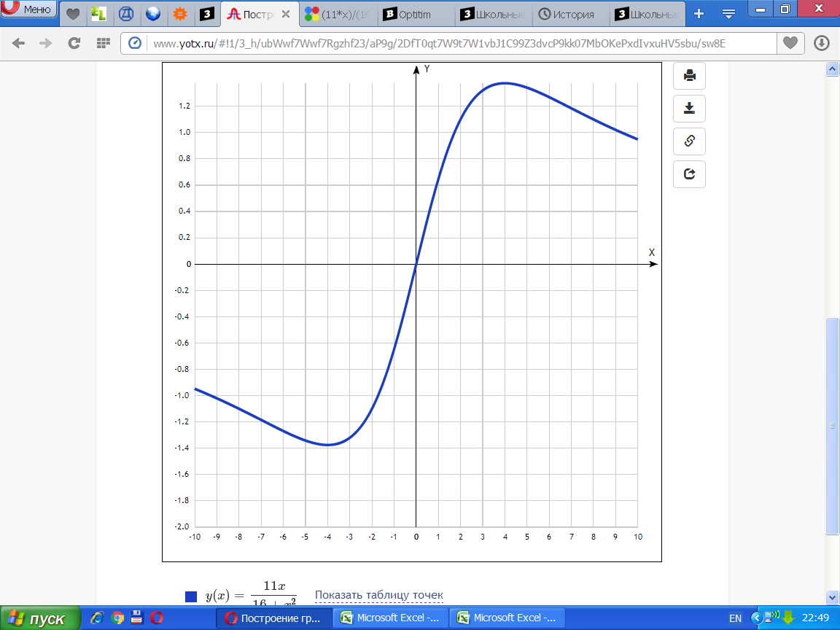

[Таблица точек](javascript:void(0);)

|  |  |
| --- | --- |
| **x** | **y** |
| -10 | -0.95 |
| -9 | -1.02 |
| -8 | -1.1 |
| -7 | -1.18 |
| -6 | -1.27 |
| -5 | -1.34 |
| -4 | -1.37 |
| -3 | -1.32 |
| -2 | -1.1 |
| -1 | -0.65 |
| 0 | 0 |
| 1 | 0.65 |
| 2 | 1.1 |
| 3 | 1.32 |
| 4 | 1.38 |
| 5 | 1.34 |
| 6 | 1.27 |
| 7 | 1.18 |
| 8 | 1.1 |
| 9 | 1.02 |
| 10 | 0.95 |