**Exercise1**

**Usingthe Verb "To be"**

Writethe correct form of the verb "Tobe" in *present tense.*

**Example:**I (be) am happy.

**Example:**

You / We / They (be) are happy.

**1)**I(be) **am**

**2)**I(be) **am**

**3)**I(be) **am**

tired.

**7)**You(be) **are**

**8)**We(be) **are**

**9)**They(be) **are**

nice.

hungry.

late!

sleepy.

funny.

**Example:**He / She / It (be) ishappy.

**4)**He(be) **is**

**5)**She(be)  **is**

**6)**It (be) **is**

cool.

pretty.

fast.

**Now we’lluse nounsinsteadof**

**pronouns…**

**10)**John(be) **is**

excited.

**11)**TiffanyandUma(be) **are**

myfriends.

**12)**Ricardo, John andI(be) **are**

watching amovie.

**18)**Nikkos andBilly(be)  **are**

playing at thepark.

**19)**Thestudents(be) **are**

studyingEnglish.

13)Hadil(be)  **is**

14)Alisa(be) **is**

kind.

young.

**15)**Thehammer(be) **is**

new.

**16)**My mother and father(be) **are**

**20)**Thetest(be) **is**

hard!

cookingdinner.

**21)**My bestfriend(be) **is**

coming to myhouse.

**17)**Rachel(be) **is**

driving to

school.

a

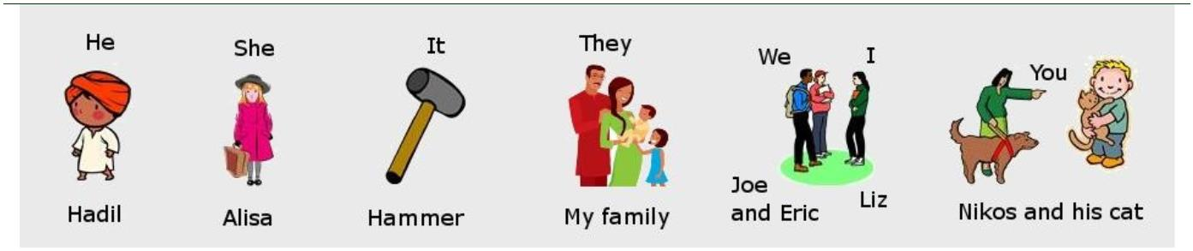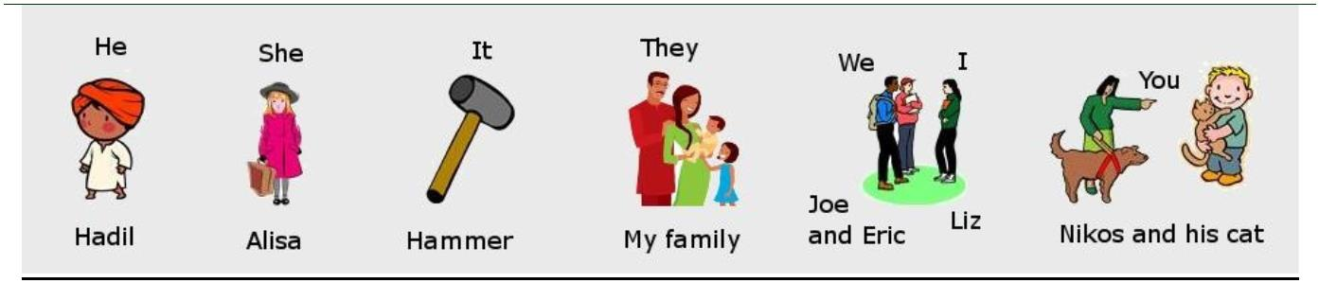

**Exercise2**

**Usingthe Verb "To be"**

Choose the correct form of "tobe" in *present tense.*

**Example:**I (be) am excited.

**Example:**Jessica and Akbar (be) are happy.

**Example:**The new car (be) is nice.

**1)**Thebag(be)

blue.

**2)**Therocks(be)

hard.

**A.**am

**B.**are

**C.**is

**A.**am

**B.**are

**C.**is

**3)**The children(be)

young.**4)**Thomas(be)

nice.

**A.**am

**B.**are

**C.**is

**A.**am

**B.**are

**C.**is

**5)**Thegame(be)

difficult.

**6)**They(be)

tired.

**A.**am

**B.**are

**C.**is

**A.**am

**B.**are

**C.**is

**7)**I (be)

thirtyyears old.

**8)**Susan andJuan (be)

married.

**A.**am

**B.**are

**C.**is

**A.**

**B.**

**C.**is

am

are

**9)**Teddy(be)

myfriend.

**10)**We(be)

in English

class.

**A.**am

**B.**are

**C.**is

**A.**

**B.**

**C.**is

am

are

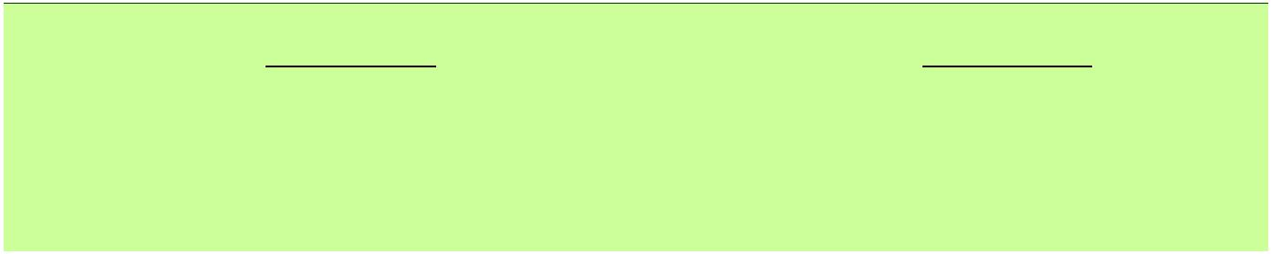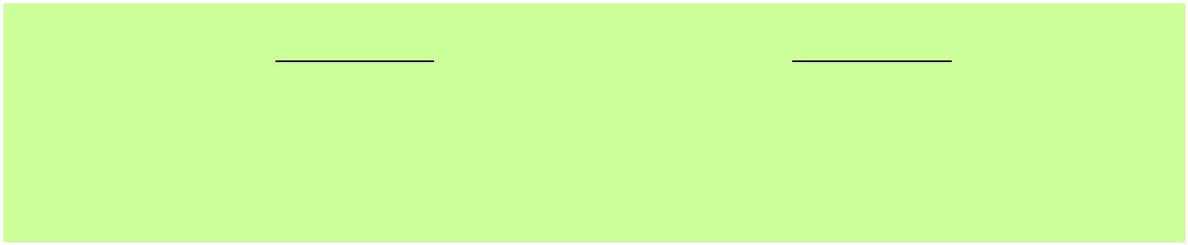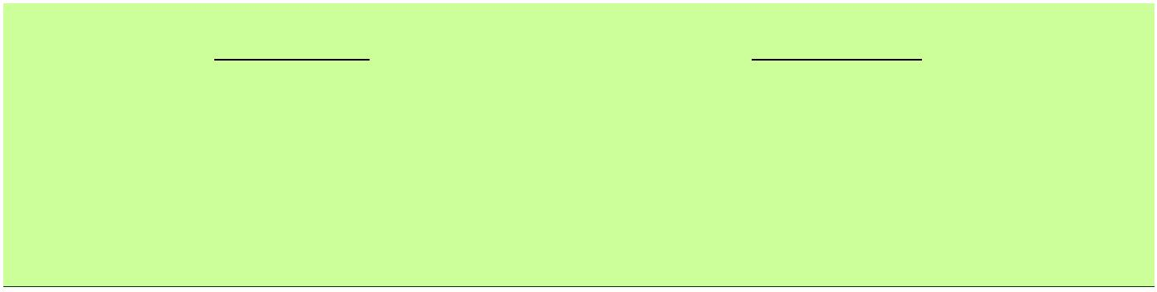

**Exercise3**

**Usingthe Verb "To be"**

Writethe correct form of the verb "tobe" in *present tense.*

**Note:** The verb can be positive (+) or negative (-). Use not to formthe negative.

\

**Example:**My teacher (be) is nice. (+)

**Example:**The cat (be, not) is not hungry. (-)

**1)**The oldman (be) **is**

wise.

**2)**Thesun (be) **is**

hot.

**3)**Thechildren(be) **are**

bananas. They(be,not) **are not**

eatingapples.

eating

**4)**I (be) **am**

happy. I (be,not) **am not**

buying a

sad.

**5)**Theracecar(be) **is**

fast.It

**6)**Myfriend(be) **is**

(be,not) **is not**

slow.

new car. Her old car broke down. It

doesn't workanymore.

**7)**I (be) **am**

at the beach with

hot and

**8)**Ko andJacob(be)  **are**

smart.Ko (be) **is**

andJacob(be) **is**

engineer.

very

a scientist

an

my family.It (be)  **is**

sunny outside. The ocean water

(be) **is**

warm.

**9)**Thelibrary(be) **is**

open

**10)**Theschool (be) **is**

small. It

until 9:00p.m.

(be,not) **is not**

big.

**11)**Thebooks (be) **are**

new.

old.

**12)** Tommy, Steven,and Teddy (be) **are**

They(be, not) **are not**

acting in the schoolplay.

**13)**Beatrice (be) **is**

at her

**14)**It(be) **is**

(be,not) **is not**

hot outside. It

coldoutside.

house.

**16)**Judith(be,not) **is not**

at

school.

**15)**You(be) **are**

finished with

home.She(be) **is**

thequiz!

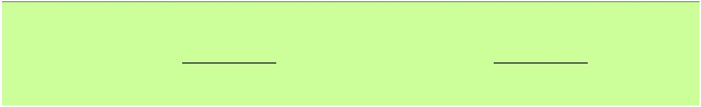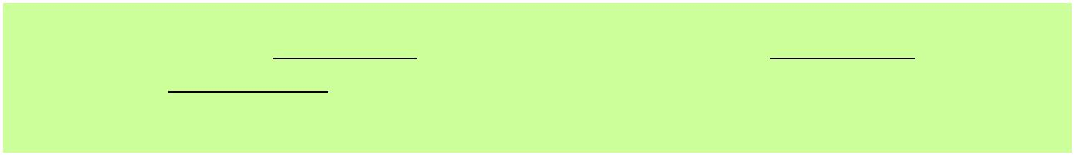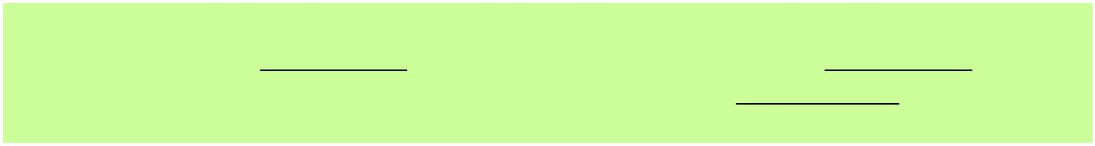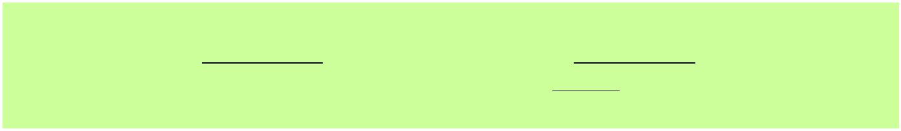

**Exercise4**

**Usingthe Verb "To be"**

Writethe correct form of "tobe" in *present tense.*

Myname(be)  **is**

on a farm.It(be)  **is**

**is not**(4) loud in thecountry.

(1)John.I(be) **am**

(2) fifteenyears old. I live

(3) in the country. It is quiet in the country. It(be,not)

I wake up early. Sometimes,I wake up before the sun rises. Sometimes, it

(5) still dark when I wake up. But I don’t mind. I like waking up that

(be) **is**

early. I like the way the country looks in themorning.

The first thing I do afterI wake up is milk the cow. After I(be) **am**

(6)

finished milking the cow, I bring the milk to my mom. I think she uses it tomake

breakfast.She makes a delicious breakfast.Mymom

(be) **is**

(7) a really goodcook.

Next, I feed the pigs. One time, I asked my mom how come my littlesister

doesn’t feed them. She said it is because my sister(be,not)  **is not**

enough. But I still don’t understand.She is almost as strong as me! I guessmy

mom doesn’t want my sister to get hurt. Afterall, the pigscan (be) **be**

(8) strong

(9)

prettyrough, especially whenthey(be) **are**

The last thing Ido (be) **is**

(10) hungry.

(11) feed the chickens. That(be) **is**

(12) easy. I just throw some food down on the ground and theyrun out

and eat it. While thechickens (be)  **are**

collect their eggs. Chickeneggs(be) **are**

(13) eating, I go into theirhouse to

(14) really good toeat.They(be) **are**

(15) easy to cook too. That is what I do in the mornings.I(be) **am**

(16) prettybusy.



**Exercise5**

**Usingthe Verb "To be"**

Writethe correct form of "tobe" in *presenttense.*

TessandJen **are**

(1) bestfriends.

They do everything together.They spend every daytogether.

One day they meet on the bus to school. They start talking.

“HeyJen,” saysTess.“How **are**

(2)you?”

“Heygirl,” saysJen.“I **am**

(5) you doingtoday?”

(3) doingfine.What **is**

(4) going on?What **are**

“Oh,”says Tess,“I **am not**

plans.”

_

(6) doing anything special.I don’thave any

“That **is**

(7) cool.”

“Yeah,”says Tess. “But I have something to tell you.”

“Really! Can I try to guess?”

“Umm…” says Tess. “Well…”

“Okay, I get three guesses.Ready?”

“Umm,well…okay.” **Are**

“

(8) we eating dinnertogether?”

“No,that **is not**

(9)it.”

“Okay. Are we going to the soccer game together?”

“No. It **is not**

(10) that either.”Tess looks nervous. Her eyes look sad.A tear

startsto fall down hercheek.

“Oh,”says Jen, wiping a tear from her own eye. “Now Iknow. You **are**

movingaway.”

(11)



**Exercise6**

**Usingthe Verb "To be"**

Choose the correct form of "tobe" in *past tense.*

**Example:**You / We / They (be) were sick yesterday.

**Example:**I / He / She / It (be) was sick yesterday.

**1)**I(be)

**D.**was

tired yesterday.

sadyesterday.

**2)**You(be)

happy

busy

yesterday.

**E.**were

**A.**was

**B.**were

**3)**We(be)

**4)**They(be)

yesterday.

**A.**was

**B.**were

**A.**was

**B.**were

**5)**He(be)

angryyesterday.**6)**She(be)

sleepy

yesterday.

**A.**was

**B.**were

**A.**was

**B.**were

**7)**It(be)

coldyesterday.

**A.**was

**B.**were

Practicewriting sentences using the verb “tobe” in *past tense*.

**1) She was here yesterday**

**2) We were calling you**

**3) He was late to class.**

